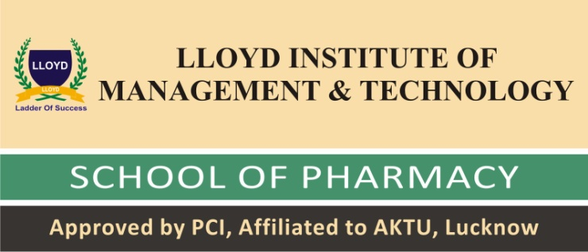
Delegate Registration Form
Generic Vs Branded Drugs – A 360⁰ overview on Costs, Benefits & Efficacy
3rd National Seminar 'PHARMA SPEAK'
on
10th November 2017
Registration No. (To be filled by the Institute) .........
Name ..................................................................................................
D.O.B. .............................. Sex (M/F)...........................
Delegate Category : Students (UG) …Students (PG)…. Faculty …Industry… Regulators….
Organization’s Name & Address ...................................................................................................................................................................................................
Contact No. ......................................................
Email : ............................................................................................................ Delegate Payment details: Enclosed is Cash / Cheque / DD No. ...................................... Of Rs. ..................................................... of Bank ....................................................................... ..................................................... Dated .....................................
Signature
Please mail us for any queries at conference2017@lloydcollege.in
(Photocopy of the form can be used or can be downloaded from www.lloydinstitute.org and submitted in hard copy in Institute)

